**Model Evaluation**

**TOTAL POINTS 2**

1.Question 1

What function randomly splits a dataset into training and testing subsets



**train_test_split**



**cross_val_score**



**cross_val_predict**

1 point

2.Question 2

Consider the following diagram of 4 fold cross-validation. From the diagram how many folds are used for testing:

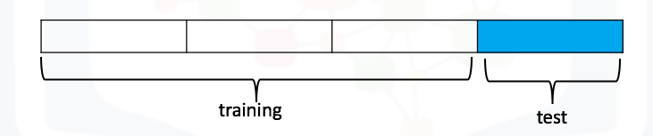



4



1



3

1 point